Asia-China-Bronze-Figure terms

Animal mask 兽面Shòu miàn

Taotie 饕餮Tāotiè

body, torso 身躯Shēnqū

paws 或足huò zú

foot 脚 Jiǎo

eyes眼，yǎn

eyebrows眉méi

ears 耳zuǐ

mouth 嘴zuǐ

teeth 牙yá

lower jaw-下颚xià'è

body 身躯shēnqū

Dragons龙Lóng

Animal Mask 兽面Shòu miàn

phoenix 凤Fèng

Bird 鸟纹Niǎo wén

animal动物n Dòngwù

各种动物A variety of animals

pattern 纹, wén

fire lines 火纹, Huǒ wén

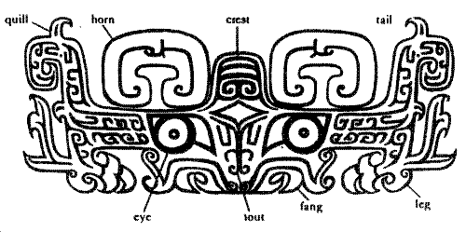

SHAPE \\* MERGEFORMAT 